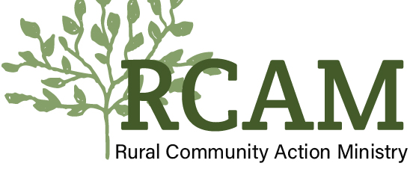

Volunteer Guidelines

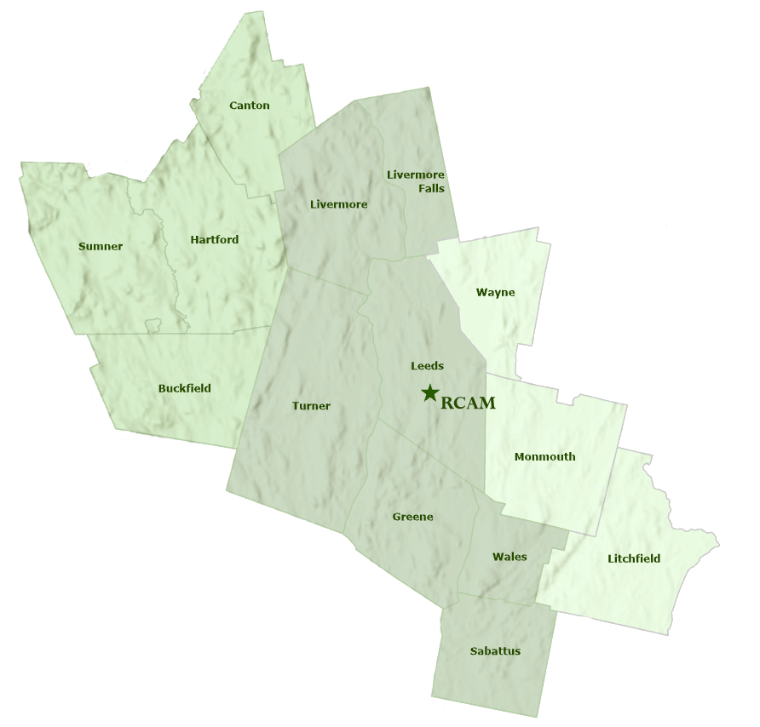

81 Church Hill Rd., Leeds, ME 04263— 207.524.5095
www.rcam.net
Table of Contents
Introduction |  |  |  | 3
Purpose of the Volunteer Guidelines |  |  |  | 3
About Rural Community Action Ministry |  |  |  | 3
RCAM Services |  |  |  | 3
RCAM Statement on Diversity, Equity, and Inclusion |  |  |  | 4
Drug-Free Workplace |  |  |  | 4
Volunteer Screening |  |  |  | 5
Sexual Harassment |  |  |  | 5
Confidentiality |  |  |  | 6
Boundaries |  |  |  | 6
Gifts and Gratuities |  |  |  | 6
Volunteer Files |  |  |  | 6
Volunteer Drivers |  |  |  | 7
References/Requests for Information |  |  |  | 7
Documentation |  |  |  | 7
Attendance/Punctuality |  |  |  | 7
Conduct/Appearance |  |  |  | 7
Personal Beliefs |  |  |  | 7
Conflict Resolution |  |  |  | 8
Safety |  |  |  | 8
Accident Reporting |  |  |  | 8
Office Closings |  |  |  | 8
Liability |  |  |  | 9
Volunteer Orientation/Training |  |  |  | 9
Exit Interview |  |  |  | 9
Volunteer Guidelines Acknowledgement |  |  |  | 9

Introduction
Purpose of the Volunteer Guidelines
Rural Community Action Ministry (RCAM) continues to follow its mandate to confront poverty on three levels— the individual, the family, and the community. Volunteers are essential to the work that we do to meet the needs of all the people we serve. We value our volunteers and the commitment they make to helping RCAM help others. These volunteer guidelines are in place to help us provide the best possible information to our volunteers in order to support each volunteer and help them understand our organization and its policies.
About Rural Community Action Ministry
“Rural Community Action Ministry reaches out to people in rural Maine who are in need and assists them to help themselves.”
Rural Community Action Ministry is a private non-profit agency, incorporated in 1970 as a nonprofit 501(C)3 and governed by a Board of Directors comprised of residents of the 14 rural towns served by RCAM representing diverse occupations, sectors and perspectives. RCAM works with the support of diverse funders, community partners, elected officials, residents, community service providers, and private donors to achieve its mission.
The mission of the agency — “Rural Community Action Ministry reaches out to people in rural Maine who are in need and assists them to help themselves.” The Comprehensive Community Assessment provides an analysis of the complex community needs in Androscoggin, Kennebec and Oxford counties and describes the challenges for people to achieve economic security and well-being. RCAM was founded in 1970 by an ecumenical group of ministers from fifteen area churches. These ministers had a vision: churches that work together can do far more to help rural Mainers than can one church working alone. Now, a solely secular organization, that cooperative spirit is still the driving force behind delivering services to people in need in 14 towns of Androscoggin, Kennebec, and Oxford counties. Throughout its history, RCAM has formed partnerships and networks that created services to help people help themselves. Today, RCAM works with and is financially supported by other organizations, foundations, town, state and federal entities, and private individuals, as well as local and out-of-state churches. RCAM also receives funding from the United Ways of Androscoggin County, Kennebec Valley, and Tri-Valley; as well as the towns of Buckfield, Canton, Greene, Hartford, Leeds, Litchfield, Livermore, Livermore Falls, Monmouth, Sabattus, Sumner, Turner, Wales and Wayne.
Rural Community Action Ministry Services
During the more than 50 years of providing services and resources to people seeking to improve their quality of life, Rural Community Action Ministry has been stalwart in its desire to connect services to actual community needs, using community needs assessments as a key part of its planning cycle to determine gaps in service, and to forecast emerging issues and trends.
Current efforts include services for housing repair and rehabilitation, homelessness prevention services, transportation for the elderly, self-sufficiency services for rural families and seniors, financial literacy education, gardening, support of food banks that are operated by churches and towns, and assistance for shelter and other needs. RCAM also provides clients with information and refers them to other organizations that offer key resources.

Volunteer support is vital in helping RCAM carry on its work. Local volunteers help clients directly and serve on the Board of Directors in assisting a small staff to plan and implement the services. Many churches and hundreds of volunteers have come during the summer months to repair houses and work with other RCAM services.

RCAM Statement on Diversity, Equity, and Inclusion
Rural Community Action Ministry (RCAM) is committed to the principles of diversity, equity, and inclusion and to engaging a full range of perspectives, ideas, and experiences to help us achieve our collective goals. Diversity, equity, and inclusion are vital to living our values and advancing the common good. Rural Community Action Ministry takes the broadest possible view of diversity, going beyond visible differences to affirm the essence of all individuals including the realities, backgrounds, experiences, skills, and perspectives that make all people who they are. RCAM works to make sure everyone can live healthy, engaged, and secure lives as they live and age in homes and communities. We commit to deepening our understanding of diversity, equity, and inclusion.
Drug-Free Workplace
RCAM provides a safe, healthy, and productive work environment for all volunteers and employees. It is the organization’s policy that volunteers shall not be involved with unlawful (under either state or federal law) use, possession, sale, or transfer of drugs or narcotics in any manner that may impair their ability to perform assigned duties or otherwise adversely affect the organization’s ability to conduct business. Volunteers shall not consume, have in their system, possess, sell or transfer illegal drugs, illegal narcotics or alcoholic beverages in the workplace or during work time. Being under the influence of alcohol or illegal drugs (as classified under federal, state, or local laws, including marijuana), while on the job poses serious health and safety risks to other volunteers, employees, and the individuals we serve.
RCAM prohibits the use of, possession of, or influence of marijuana (cannabis) while volunteering. A volunteer may be asked to leave for being under the influence of marijuana while volunteering. This follows federal law.
Nothing in this policy is meant to prohibit the appropriate use of over-the-counter medication or other medication that can legally be prescribed under both federal and state law, to the extent that it does not impair a volunteer's job performance or safety or the safety of others. Volunteers who take over-the-counter medication or other medication that can legally be prescribed under both federal and state law to treat an ailment should inform the Volunteer/Youth Services Coordinator if they believe the medication potentially could impair their job performance, safety, or the safety of others or if they believe they need a reasonable accommodation before reporting to volunteer while under the influence of that medication.
If a volunteer has questions concerning this policy or about workplace substance abuse that is not addressed in this policy, please contact the Volunteer/Youth Services Coordinator or Executive Director.

Volunteer Screening
Volunteers may be screened through but not limited to the State Bureau of Identification (Criminal Records), the Department of Motor Vehicles and/or the Department of Health and Human Services. The volunteer will be asked to sign a release to consent to this screening as part of the application process. If a conviction is disclosed, the volunteer’s record will be reviewed by the Volunteer/Youth Services Coordinator to determine acceptance of the volunteer.
Sexual Harassment—Policy and Procedures
It is RCAM’s policy to create and maintain a volunteer experience free of all forms of discrimination, including sexual harassment. Sexual harassment is unlawful and will not be tolerated by RCAM.
Meaning of Sexual Harassment: Sexual harassment means any harassment based on someone’s sex or gender. It includes harassment that is not sexual in nature (for example, offensive remarks about an individual’s sex or gender), as well as any unwelcome sexual advances or requests for sexual favors or any other conduct of a sexual nature, when any of the following is true:
- Submission to the advance, request or conduct is made either explicitly or implicitly a term or condition of a volunteer’s involvement.
- Submission to or rejection of the advance, request or conduct is used as a basis for volunteer task decisions affecting the individual.
- Such advances, requests or conduct have the purpose or effect of substantially or unreasonably interfering with an individual’s performance by creating an intimidating, hostile or offensive environment.

RCAM will not tolerate any form of sexual harassment, regardless of whether it is:
- Verbal (for example, epithets, derogatory statements, slurs, sexually related comments or jokes, unwelcome sexual advances or requests for sexual favors).
- Physical (for example, assault or inappropriate physical contact).
- Visual (for example, displaying sexually suggestive posters cartoons or drawings, sending inappropriate adult-themed gifts, leering or making sexual gestures).

If a volunteer believes that he or she has been subjected to sexual harassment, the volunteer is encouraged to report the problem to the Volunteer/Youth Services Coordinator. If that is not possible, a complaint may be presented to the Executive Director.

The complaint will be investigated. A volunteer also has the right to seek resolution outside of the organization by filing a complaint with the Maine Human Right Commission. At the volunteer’s request, to the extent possible, complaints will be handled on a confidential basis. Every volunteer has the right to report any sexual harassment without fear of jeopardizing her/his position. Appropriate disciplinary action, including suspension, demotion, or discharge, will be taken against any volunteer/ employee committing sexual harassment.

Confidentiality
No volunteer or staff member shall divulge any personal client information without prior authorization by the Director and/or the client except in cases where there is a need to access emergency intervention when someone’s life or safety is in danger. In these cases, it is essential to report this action immediately to the supervisor or Director.
No volunteer or employee shall, either during the term of working with RCAM or after leaving any involvement with RCAM, disclose to any person, firm, corporation, or other entity, except upon direct authorization by the Director or the client as required by law, information pertaining to any of the following: client lists, data, figures, estimates, personnel history, accounting procedures, non-public information on projects and the like. All such personal client information shall be considered confidential and kept as the private and privileged records of RCAM.
It is of the utmost importance to RCAM and the clients it serves that the clients know that all information shall be kept confidential and that all volunteers and employees of the organization shall be bound by this confidentiality. Should any volunteer or former employee breach this agreement, RCAM shall be entitled to seek an injunction issued by a court to enjoin and restrain the unauthorized disclosure of such information.
Boundaries
Clients cannot be sheltered at the home of any volunteer at any time. The Homelessness Prevention Services program is available to find placement for homeless clients. Volunteers are not employees of RCAM and should not represent themselves as employees at any time.
Gifts and Gratuities

Volunteers cannot accept gifts or gratuities from a client or organization as an incentive for RCAM to provide services. Token gifts of appreciation are acceptable.

Volunteer Files

RCAM will maintain a file on each volunteer which will contain the application, volunteer assignments, references and other materials related to assignments and performance. Volunteers may review their own file by making an appointment with the Volunteer/Youth Services Coordinator. Copies of any material in the file may be requested by the volunteer.

Volunteer Drivers

Volunteer drivers for RCAM need to review and agree to specific guidelines to be provided the Volunteer/Youth Services Coordinator. Completed mileage reimbursement request forms are expected to be submitted at the end of every month. Volunteers should count on a 15-day turnaround for processing and payment.

References/Requests for Information

The only information that will be provided about a volunteer without specific permission are the dates of involvement with RCAM. Before any information is released the volunteer must give written permission. Volunteers are encouraged to use their volunteer experiences as references for employment opportunities. A signed Reference Release form will be kept in volunteer’s files. Applications listing RCAM as a reference will qualify as written permission for release. Records will be kept for five years on all volunteers.

Documentation

All volunteers will be supplied with a Volunteer Sign-In sheet to be filled out and turned in at the end of every month. Volunteers will learn how to complete these and where to forward them during volunteer orientation. Volunteers are expected to submit information in a timely fashion. This is important because RCAM tracks volunteer time as a demonstration of in-kind support and its value. Often, potential funders request this information as part of a decision-making process when determining grant awards.

Attendance/Punctuality

Volunteers and their supervisors will establish a schedule. If a volunteer has a change in priority, schedule, etc., and is unable to carry out a scheduled task, a 24-hour notice is requested except in the event of an emergency. Volunteers are expected to arrive on time based on the schedule planned with supervisors.

Conduct/Appearance

Volunteers represent RCAM. While RCAM does not have a specific dress code, volunteers are encouraged to wear clothing suitable for the task they have been assigned. Personal hygiene should be maintained.

Personal Beliefs

RCAM understands that volunteers, staff, and clients hold a wide range of personal beliefs, values, and commitments. RCAM values and respects these differences and has an expectation that no individual will use their time at RCAM to attempt to influence others. Any individual who feels as though their personal beliefs and values are causing them to be discriminated against is encouraged to have a conversation with the appropriate person so any issues can be resolved. RCAM’s executive director has an open- door policy and will make time for these difficult conversations. There may be circumstances where it is determined that volunteering at RCAM is not a good fit for the volunteer.
Conflict Resolution
All volunteers should attempt to resolve a conflict by first talking with the person or persons involved. Any volunteer who has a concern, suggestion, or objection concerning RCAM, its employees or other volunteers is encouraged to bring the matter to the attention of their supervisor or the Volunteer/Youth Services Coordinator. If the issues remains unresolved, volunteers may wish to bring it to the attention of the Executive Director.

Safety
It is the goal of RCAM to provide all volunteers with a safe and healthy workplace.

While RCAM will endeavor to provide safe and healthful conditions for each of its volunteers, the organization requires that each volunteer recognize their obligation to conduct themselves with regard for their own safety and for the safety of their fellow volunteers, employees, and clients.

Each volunteer is required to read and sign-off on the RCAM Safety Manual.

Accident Reporting

Whenever possible and regardless of the severity, if a volunteer, client, visitor, or employee is injured and/or involved in an accident while on RCAM property, while traveling in an RCAM vehicle, operating RCAM equipment or while acting on behalf of RCAM, the incident must be reported within twenty-four (24) hours to the Executive Director or his/her designee. An accident form will be completed and filed.

Office Closings

All volunteer tasks/assignments will be cancelled if the office closes. No volunteers are scheduled for days when the office is regularly closed. RCAM closes its office for all official holidays—a list of these closings are listed in the RCAM Personnel Manual. Since COVID19, there may be times when the office is closed to protect the safety of volunteers, staff, and clients. In those instances, the Volunteer/Youth Services Coordinator will notify any volunteer scheduled to be in the office.

Hazardous/Severe weather may warrant the office being closed with little advance notice. In general, RCAM’s office is closed whenever local schools announce closure for storm days. Volunteers are encouraged to contact their supervisors to confirm whether the office is open prior to reporting for a scheduled assignment. When the office is open despite hazardous weather, volunteers should exercise their own judgement based on safety while traveling, and notify RCAM if they choose not to travel.

Liability

All volunteers must sign an Assumption of Risk and Release. Any person who volunteers for RCAM’s Volunteer Driver program, which transports clients or other volunteers must submit copies of a valid driver's license and proof of car insurance for their volunteer file. Insurance companies vary and it is the responsibility of the volunteer to check whether an insurance Rider on their individual policy is needed if they are volunteering to transport individuals. Volunteers transport only with the understanding that in the event of an accident their personal insurance is the primary coverage. Volunteers are insured under RCAM’s general liability insurance coverage while performing tasks for RCAM.

Volunteer Orientation and Training

All volunteers will attend an orientation and training meeting which will cover topics including the Mission, Purpose, and History of RCAM, RCAM policies and procedures, Volunteer Guidelines, and volunteer training/orientation for specific assignments.

Volunteers will be made aware of relevant training opportunities and will be encouraged to attend. Whenever possible RCAM will apply for scholarships for volunteer workshops.

Exit Interview

It is RCAM’s goal to make its Volunteer Program a positive experience for everyone. Each exiting volunteer with meet with the Volunteer/Youth Services Coordinator to discuss (1) the volunteer’s reason for leaving, along with suggestions and recommendations for program improvement; and (2) return of all agency property, equipment, and materials.

Volunteer Guidelines Acknowledgement

I have read these Volunteer Guidelines and I understand them. I have been given the opportunity to ask questions I needed to clarify the guidelines. By signature below, I agree to follow the guidelines.

Printed Name:

Signature:

Date:

